Analytics Review SOP
Check your analytics thoroughly once a month rather than frequently and haphazardly. Daily fluctuations are normal in this business, but don't let them influence you.
What really matters is how things develop from month to month and year to year, not how they look daily.

Analytics Review SOP
- Review your site in your ad program:
  - Which articles have relatively high RPMs and got more clicks?
  - For example, in Raptive: go to Earnings > By Traffic Source > Pinterest > Toggle to Pageviews. This shows you which articles got the most clicks and their RPMs over the last 30 days.
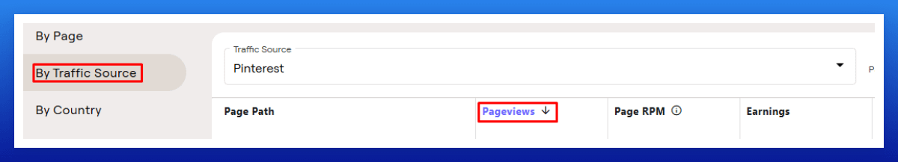
- For those with good clicks and RPMs, consider creating more pins (like another 20-25 with different titles, descriptions, and possibly different URLs) and researching new KW variations.
I usually do a mix of both.
- I also review my save rate, engagement, and outbound click rate, as well as how quickly new pins start getting impressions.
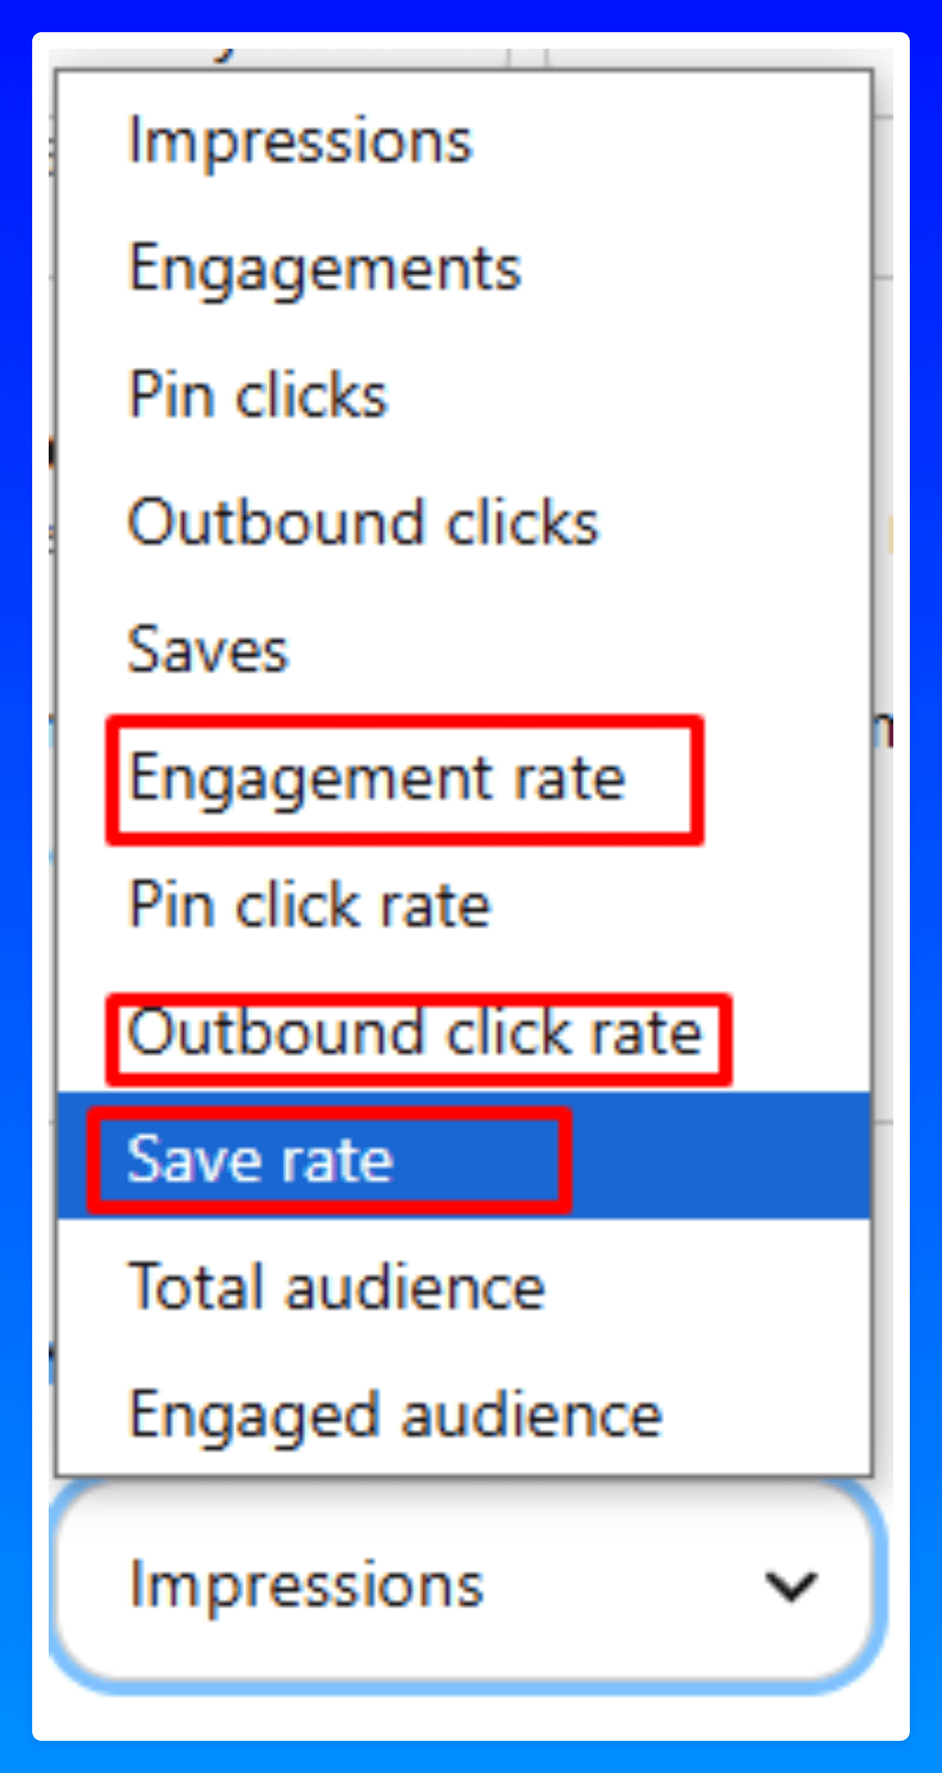
If your newly uploaded pins still have 0 impressions after several days, it’s an early sign that your engagement and save rates are dropping, and Pinterest is showing your pins less frequently.
- I also analyze which pins received the most outbound clicks in the last 30 days and look for patterns—such as whether text overlays, collages, or plain images perform best.
Once I identify a pattern, I focus more on those high-performing formats to maximize results.

